UNIGLOBE COLLEGE

**(Affiliated to Pokhara University)**

New Baneswor, Kathmandu



**Third Semester Project Report**

**on**

**“AnonAeon: Anonymous Feedback Wall”**

**(CMP273)**

A Third Semester Project Report submitted in the partial fulfillment of the requirements for the degree of Bachelor of Computer System and Information Technology awarded by Pokhara University

**Under the supervision of**

**Bipin Maharjan**

**Lecturer/Supervisor**

**Submitted By:**

**Shulabh Shrestha (P.U. Registration No. 2024-2-08-0747)**

**Submitted To:**

**UNIGLOBE COLLEGE**

**Department of Computer Science and Information Technology**

**New Baneswor, Kathmandu, Nepal**

**January, 2026**

**“AnonAeon: Anonymous Feedback Wall”**

**(CMP273)**

A third semester project report submitted in partial fulfillment of the requirements for the degree of Bachelor of Computer System and Information Technology awarded by Pokhara University

**Submitted By**

Shulabh Shrestha (P.U. Registration No. 2024-2-08-0747)

**Submitted To**

**UNIGLOBE COLLEGE**

**Department of Computer Science and Information Technology**

**New Baneshwor, Kathmandu, Nepal**

**November, 2025**

# TABLE OF CONTENTS

Table of Contents

TABLE OF CONTENTS 3

ABBREVIATIONS 7

CHAPTER 1: INTRODUCTION 1

1.1 Background 1

1.2 Problem Statement 1

1.3 Objectives of the Project 1

1.4 Scope of the Project 2

1.5 Limitations of the Project 2

1.6 Significance of the Study 2

CHAPTER 2: LITERATURE REVIEW 3

CHAPTER 3: SYSTEM ANALYSIS AND DESIGN 9

3.1 Project Management Strategy and Development Tools 9

3.1.1 Project Team 9

3.1.2 Project Flow and Schedule 9

3.1.3 Responsibilities 10

3.1.4 Development Tools 11

3.2 System Analysis 12

3.2.1 Requirement Analysis 12

3.2.2 Feasibility Analysis 13

3.3 System Design 15

3.3.1. System Flowchart 15

3.3.2 Workflow 16

3.3.4 ER Diagram 17

3.3.5 Use Case Diagram 18

3.3.6 Sequence diagrams 19

CHAPTER 4: SYSTEM IMPLEMENTATION 23

4.1 Project Schedule 23

4.1.1 Detailed Time Schedule 23

4.1.2 Detailed Gantt Chart 24

4.2 Implementation 24

4.2.1 User Authentication Module 24

4.2.2 Room Management Module 24

4.2.3 Room Viewing Module 25

4.2.4 Feedback Submission Module 25

4.2.5 Feedback Display Module 25

4.2.6 Admin Management Module 25

4.2.7 Database Implementation Module 26

4.3 Result 26

References 29

# ABBREVIATIONS

|  |  |
| --- | --- |
| CSS  HTML  JS  SQL  PHP  XAMPP | Cascading Style Sheet  Hyper Text Markup Language  JavaScript  Sequence Query Language  Hypertext Preprocessor  Cross-Platform (X), Apache (A), MariaDB (M), PHP (P), and Perl (P) |
|  |  |
|  |  |
|  |  |
|  |  |

# CHAPTER 1: INTRODUCTION

## Background

Feedback mechanisms are essential tools for driving improvement and fostering engagement in both professional and educational settings. While traditional methods like standardized forms and annual surveys provide formal metrics, they often lack the immediacy and candor required for effective, continuous quality improvement [1, 2]. The integration of real-time, anonymous feedback systems has emerged as a promising strategy to overcome these limitations, providing a direct channel for stakeholders to communicate their experiences and concerns without fear of negative repercussions [1]. This approach is increasingly vital in high-stakes environments such as medical education and clinical healthcare settings.

## 1.2 Problem Statement

Traditional, non-anonymous feedback systems often fail to capture honest and detailed qualitative data due to the inherent reluctance and fear of identification among students and staff [1]. This gap limits the ability of institutions to quickly identify and act upon factors that critically impact staff satisfaction, student engagement, and the quality of service delivery [1, 2].

## 1.3 Objectives of the Project

The Objectives of the Project are as follows:

- To create a secure feedback system with optional anonymous posting.  
- To allow administrators to manage feedback and users effectively.

## 1.4 Scope of the Project

The system allows login, creating a room for feedback, posting feedback, viewing the feedbacks in rooms, and admin features such as deleting and editing rooms, feedback and users.

## 1.5 Limitations of the Project

The system does not include advanced analytics, sentiment analysis, or real-time notifications.

And since the identity is optionally hidden, the users might take advantage of this scope of this project and use it with ill intent.

## 1.6 Significance of the Study

The studies are significant because they demonstrate that anonymous, real-time feedback is highly effective at increasing the volume and actionability of qualitative data, providing crucial insights into new learning strategies and specific workplace issues that standardized metrics overlook [1, 2]. This approach offers a powerful strategy for improving organizational culture and service quality across diverse sectors

# CHAPTER 2: LITERATURE REVIEW

**Digital Feedback Mechanisms: A Comprehensive Review**

The concept of feedback, long established as a cornerstone of communication, evaluation, and improvement, has undergone a profound transformation with the rise of digital technologies. These modern Digital Feedback Mechanisms offer unprecedented speed, anonymity, real-time capability, and expansive reach, moving far beyond the limitations of traditional, paper-based or face-to-face methods. This review explores the broad application and critical implications of these digital systems, particularly in the fields of education and organizational development, as well as in software and mobile application engineering.

A primary advantage of the digital shift is the introduction of real-time feedback, a crucial feature capable of capturing the immediate experience and engagement of users, whether they are students engaged in a learning process or staff navigating an organizational structure [1], [2]. Furthermore, the capacity of digital tools to ensure anonymity is highly significant, acting as a catalyst for honest and unfiltered responses, especially in environments where hierarchical structures might otherwise inhibit truthful communication due to fear of judgment or reprisal [1], [2].

**Digital Feedback in Learning and Organizational Environments**

The education sector has benefited immensely from the evolution of digital feedback, which enables a transition from static, post-event critiques to dynamic, continuous evaluation. This evolution is essential for both accurately gauging student engagement and actively enhancing learning outcomes.

A major challenge in traditional pedagogy—the accurate assessment of student involvement during instruction—is effectively addressed by implementing real-time, anonymous feedback channels [1]. Research by Shaheen et al. (2021) demonstrated that the use of anonymous, real-time feedback successfully captures student engagement, creating a psychologically safe environment where students can freely express confusion, clarity, or preferences regarding the pace of instruction without fear of individual identification [1]. This immediate feedback loop allows educators to rapidly make adjustments to their content, delivery methods, or pacing, thereby making the learning experience significantly more adaptive and centered on the student's needs.

The effectiveness of real-time, anonymous feedback extends seamlessly into organizational settings. Frampton et al. (2017) highlighted its considerable utility in improving staff experience and engagement within an organizational context [2]. By offering a continuous, secure channel for personnel to articulate concerns or propose improvements, organizations can pre-emptively address systemic issues, leading to substantial improvements in morale, staff retention, and overall quality of work [2].

Beyond its immediate, in-class or in-meeting utility, web-based systems have become standard for delivering structured feedback, especially following summative assessments. However, simply migrating the delivery channel to a digital platform introduces a new challenge: ensuring students effectively engage with the feedback they are provided [3]. Harrison et al. (2013) investigated medical students’ interaction with web-based feedback following assessments, underscoring the necessity of understanding student behavior—specifically, what they prioritize in the feedback and what motivates them to access and apply it [3]. The mere availability of digital feedback is insufficient; its structure, timing, and perceived relevance must be meticulously optimized to ensure student uptake and benefit.

The documented effects of web-based feedback on students' learning show potential benefits, though they are often conditional [4]. Van Kol and Rietz (2016) demonstrated that structured, web-based feedback can improve learning outcomes, but its efficacy is highly dependent on the design of the feedback interface, the clarity of the comments, and the self-regulatory capacity of the students themselves [4]. This finding clearly indicates that instructional design principles must be integrally applied when developing any digital feedback interface to maximize its educational impact.

Furthermore, the utilization of online tools in feedback provision is not confined to academia; it is recognized as a vital mechanism in **management and corporate strategy** [5], [6]. Piatnychuk et al. (2022) discussed how online tools facilitate management functions by enabling the efficient collection and analysis of feedback from diverse stakeholders, which is crucial for informed decision-making and strategic planning [6]. At the corporate interface level, effective feedback implementation is considered an **essential element of modern corporate websites** [5]. Golchevskiy and Yermolenko (2021) noted that robust feedback systems on a corporate site not only improve the user experience but also provide valuable business intelligence, allowing for continuous refinement based on user input and positively influencing overall organizational performance [5].

**Digital Feedback in Software and Mobile Application Development**

The mobile application domain is a quintessential example of where digital feedback mechanisms are not just useful, but critical. Due to rapid iteration cycles and intense market competition, the ability to understand and act swiftly on user input is paramount for success.

Traditional user feedback for mobile applications, often derived from app store reviews, is typically retrospective, unstructured, and delivered long after the issue occurred. This limitation has spurred the creation of highly sophisticated in-app and automated feedback tools [7], [9].

Scherr et al. (2017) introduced an automated feedback-based approach to support mobile app development [7]. This system is engineered to capture both technical diagnostics and user interaction data alongside explicit feedback. This capability allows developers to immediately link a reported issue to the specific state of the application at the precise moment of failure, thereby enriching the data with crucial context. This automation significantly accelerates the improvement cycle by delivering richer, more precise data than standard text reviews [7].

Building on this, Scherr et al. (2022) refined the focus to the emotional and qualitative aspects of the user experience through the development and evaluation of an in-app feedback tool designed to capture *how the app made the user feel* [9]. This represents a crucial shift from mere bug reporting to capturing nuanced data on usability, frustration levels, and satisfaction in a context-aware manner. Such qualitative, in-app data is extremely valuable for improving the User Experience (UX) and the overall product design [9]. Critically, the design of the feedback tool itself—its ease of use and level of intrusiveness—is shown to heavily influence both the quantity and the quality of the feedback elicited.

Digital feedback systems are also adapted for highly specialized applications, such as those related to safety and transportation. Driver Feedback Mobile Apps, for example, employ digital mechanisms to modify user behavior [8]. Soriguera and Miralles (2016) detailed how these apps provide real-time feedback on driving behaviors—like harsh acceleration or abrupt braking—with the aim of promoting safer and more fuel-efficient driving [8]. In this specific context, the feedback is immediate, behavioral, and quantitative, illustrating the high versatility of digital mechanisms beyond simple textual commentary.

Despite the rise of in-app tools, traditional app store user reviews remain a massive, though often noisy, source of user feedback. The sheer volume and unstructured nature of this data present a significant challenge for analysis. Fu et al. (2013) addressed this by focusing specifically on negative sentiment—"Why people hate your app"—developing advanced data mining methods to automatically make sense of user feedback in a mobile app store [10]. Their research used computational techniques to categorize and prioritize common complaints, effectively converting thousands of reviews in natural language into actionable intelligence for the development team [10]. This work emphasizes that effective feedback collection must be paired with sophisticated analytical tools to efficiently extract meaningful information from large, raw datasets.

**Core Design and Methodological Principles**

The literature reviewed consistently demonstrates that the design and careful implementation of a digital feedback mechanism are paramount to its success. Several key principles are recurring across the diverse research contexts:

The guarantee of anonymity is a recurring, essential feature, particularly when the feedback relates to evaluation, performance, or sensitive personal disclosure [1], [2]. By ensuring the feedback is decoupled from the provider’s identity, individuals feel empowered to offer more candid and constructive criticism. This is especially vital in hierarchical settings like educational institutions or corporate workplaces, where the dynamics of power might otherwise suppress honest communication [1], [2]. A robust digital system must secure the integrity and security of this anonymity feature.

The maximization of value in feedback is achieved when it is both contextual and timely [1], [7], [8]. Real-time systems, whether used to track student engagement in a lecture [1] or to automate bug reporting in a software application [7], provide data directly correlated with the moment of experience or interaction. This immediacy allows for rapid, precise intervention or analysis, drastically improving the efficiency of the feedback loop. For example, providing quantitative feedback on driver behavior *during* the act of driving is far more impactful than a generalized weekly summary [8].

The interface design of the feedback mechanism is a direct determinant of user engagement [3], [9]. For students, the structure and clarity of web-based post-assessment feedback critically determine whether they choose to access and utilize it [3]. For mobile app users, the in-app tool must strike a balance: it must be accessible yet non-intrusive, and its design must facilitate the clear expression of nuanced experiences, including emotional states [9]. A poorly designed digital feedback tool can itself become a source of user frustration, leading to low participation rates or poor data quality.

Finally, the transition to digital platforms inevitably results in an exponential increase in data, making analytical efficiency a central concern [10]. Tools must be capable not merely of collecting feedback but of rapidly processing and transforming massive volumes of unstructured data (such as user comments) into prioritized, actionable insights [10]. Research in this area strongly advocates for the integration of advanced data mining and machine learning techniques to automate the interpretation of user input, enabling stakeholders to quickly identify and address the most critical issues.

**Concluding Synthesis**

The collective research emphatically supports the view that Digital Feedback Mechanisms are transformative tools. They have successfully shifted feedback from a limited, periodic event to a continuous, real-time process that forms the foundation of quality assurance, drives engagement, and steers product development.

In diverse educational and organizational contexts, digital systems effectively utilize immediacy and anonymity to capture genuine engagement and improve the experiences of both students and staff [1], [2]. Web-based platforms, while providing crucial accessibility, require sophisticated design to ensure high levels of student engagement with the feedback content itself [3], [4].

In the mobile application ecosystem, in-app and automated tools deliver the rich, contextual data necessary for the high-velocity demands of modern development cycles [7], [9]. Concurrently, analytical methodologies are continuously advancing to extract maximum strategic value from external, large-scale feedback sources like app store reviews [10].

The future trajectory of digital feedback will inevitably involve deeper technological integration, leveraging Artificial Intelligence and machine learning to offer feedback that is more personalized, adaptive, and predictive in real-time. Continued scholarly research is essential to refine the ethical and design principles for these sophisticated tools, ensuring their maximum effectiveness in driving constructive, positive change across all fields.

# CHAPTER 3: SYSTEM ANALYSIS AND DESIGN

## 3.1 Project Management Strategy and Development Tools

The project follows a structured development model using PHP, MySQL, HTML/CSS, and XAMPP.

### 3.1.1 Project Team

|  |  |
| --- | --- |
| **Team Resource** | **Role** |
| Bipin Maharjan | Supervisor |
| Shulabh Shrestha | Software Developer |

Table 2: Team Resource and Roles

The AnonAeon project by Shulabh Shrestha is supervised by Mr. Bipin Maharjan.

### 3.1.2 Project Flow and Schedule

* Team Size: 1
* Total Project Duration: 10 weeks
* Effort Required per person: 8 hours per week

### 3.1.3 Responsibilities

This section States the responsibilities of each members of the project

#### 3.1.3.1 Responsibilities of Supervisor

#### Provide guidance throughout the planning, analysis, design, and implementation phases of the project.

* Offer constructive feedback to improve system design, security, and functionality.
* Evaluate the final system, documentation, and presentation as part of academic assessment.

#### 3.1.3.2 Responsibilities of team member

* Conduct requirement analysis to understand the problem domain and define system features
* Design System Architecture, workflow diagrams, DFDs, ERDs, and use case for AnonAeon
* Develop full web application using PHP, HTML, CSS and JavaScript.
* Ensure timely completion of all project phases according to the schedule
* Prepare final report, demonstration materials, and contribute to the final evaluation process

### 3.1.4 Development Tools

Backend: PHP

Frontend: HTML/CSS/JavaScript

Database: MySQL

Server: Apache

Testing: Manual Testing

#### 3.1.4.1 Backend Tools

PHP is used for backend language as it is one of the most widely used language for server side development and it integrates seamlessly with MySQL making data handling efficient. PHP runs smoothly on apache servers providing stable environment.

#### Front End Tools

HTMLProvides the structure and layout of webpages.It is used to design components like forms, buttons, feedback cards, and navigation elements.

CSSControls the styling, appearance, and responsiveness of the website. Makes the interface visually appealing and user-friendly.It helps maintain consistency across pages such as login, feedback wall, and admin panel.

JavaScriptAdds interactivity and dynamic behavior to the web pages.JS is used for form validation, real-time UI updates, and enhancing user experience.It helps with asynchronous interactions and improves the responsiveness of the system.

#### Web Server

Apache is used as a web server because it is stable, open source and widely used in php applications.It’s fully compatible with XAMPP environments and commonly used by developers.

#### Testing Tools

Manual testing is chosen because the project is medium scale, making manual checks practical and efficient. Allows the developer to interact directly with the system identify UI/UX.

## System Analysis

The system is designed based on collected requirements for secure login, feedback posting, admin controls, and user experience

### 3.2.1 Requirement Analysis

The collected information is structured, conflicts are resolved and requirements are prioritized.

#### 3.2.1.1 Functional Requirements(FR):

* FR1: The system must allow users to register and log in using a valid username and password
* FR2: The system must allow users to post feedback in the feedback wall either anonymously or with their username visible
* FR3: The system must display all the posted feedback by the logged in users, the wall must update with newly added feedback
* FR4: The admin must be able to log in using admin credentials, must be able to view all users and feedbacks. They must also be able to delete users or feedbacks from the system. They can post as **Admin** or **Anon**.
* FR5: The system must store user details, feedback entries, timestamps and anonymity settings

#### 3.2.1.2 Non-Functional Requirements(NFR):

* NFR1: The user interface must be clean, simple and easy to navigate.
* NFR2: User passwords must be stored securely and sessions must be protected to prevent unauthorized access
* NFR3: The system should load page within 3s on standard devices. Feedback wall must handle all feedbacks without noticable delay.
* NFR4: The system should operate continuously without failure under normal conditions and system downtime should be minimized
* NFR5: The system should handle increasing numbers of users feedback entries.
* NFR6: The codebase should be modular and easy to update, documentation should be provided for future developers and system must support bug fixing without affecting data.

### 3.2.2 Feasibility Analysis

#### 3.2.2.1 Technical Feasibility

The system uses widely supported technologies(PHP, HTML, CSS, JS) which makes development practical. No advanced hardware and complex algorithms are needed.

#### 3.2.2.2 Operational Feasibility

Users can easily post messages by entering text and selecting department room. Optional anonymity encourages participation. Restricting posts to department-specific rooms keeps the app organized and reduces irrelevant messages.

#### 3.2.2.3 Economic Feasibility

Development tools like XAMPP, VS Code and MySQL are free to use and maintenance cost are low due to system’s simplicity.

#### 3.2.2.4 Time feasibility

This project is simple enough to be completed within 1-2 months even by a single person. Tasks such as UI design, backend design, database setup, and testing are manageable during this time frame.

## 3.3 System Design

### 3.3.1. System Flowchart

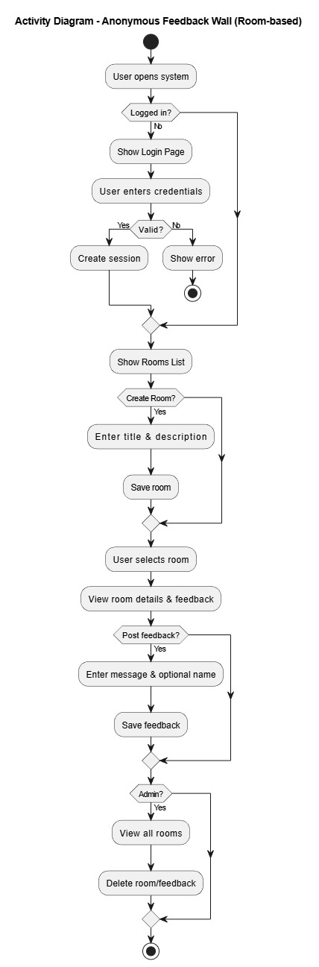

Fig 3.1 : System Flowchart

First, the system checks if the user is Already Registered; if so, they must provide Valid credentials to access the Index page, otherwise, they are redirected to the Log in page. From the Index page, if Feedback is submitted, the user is Redirected to wall page; if not, they remain on the Index page before reaching the Wall page. Finally, clicking Log out terminates the session and returns the user to the Log in page.

### 3.3.2 Workflow

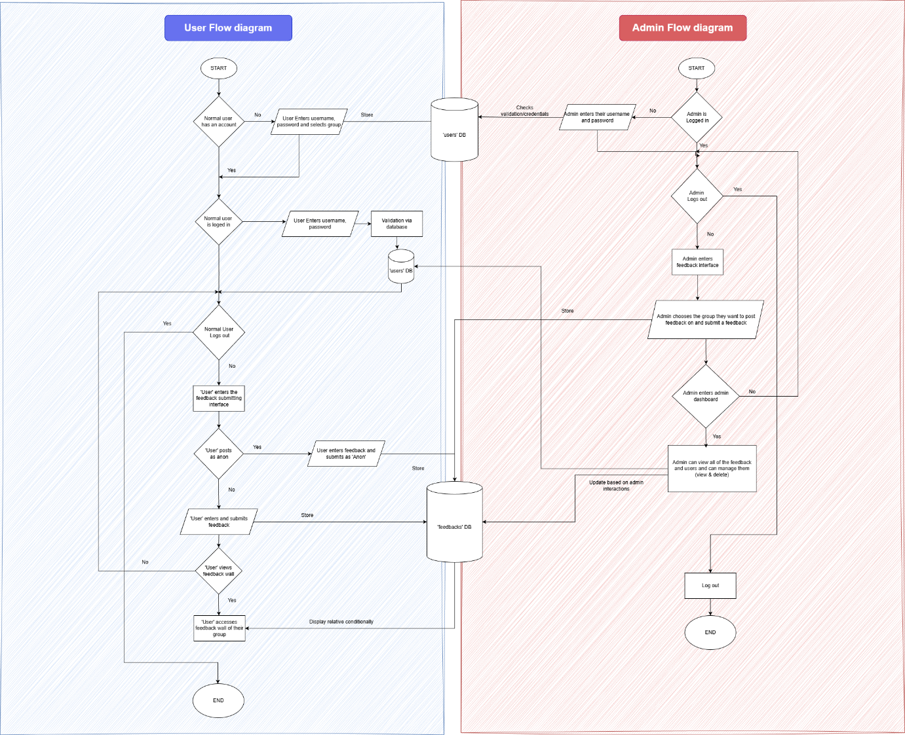

Fig 3.2 : Workflow diagram

Normal users can create an account, log in, submit feedback (anon or named), and view feedback for their group. Admins log in using their own credentials, post feedback to groups, and access the admin dashboard. Inside the dashboard, admins can view all feedback, update or delete messages, and manage group visibility. Both user and admin interactions update a shared feedback database that stores all submissions.

### 3.3.4 ER Diagram

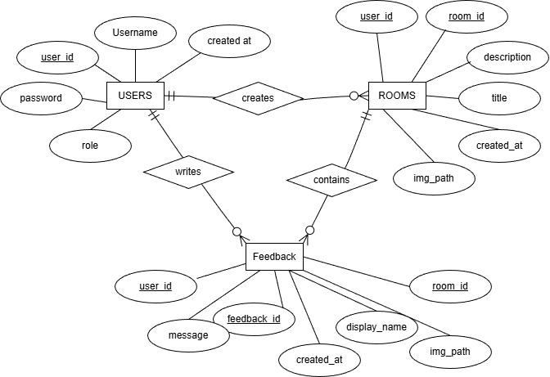

Fig 3.6: ER Diagram

The system stores users, feedback, and groups, linking them through defined relationships. Each user can submit many feedback posts, and each post belongs to one user and one group. Groups organize feedback visibility, where multiple feedback entries appear within a single group. Attributes like username, role, message, display name, and timestamps describe each entity in detail.

### 3.3.5 Use Case Diagram

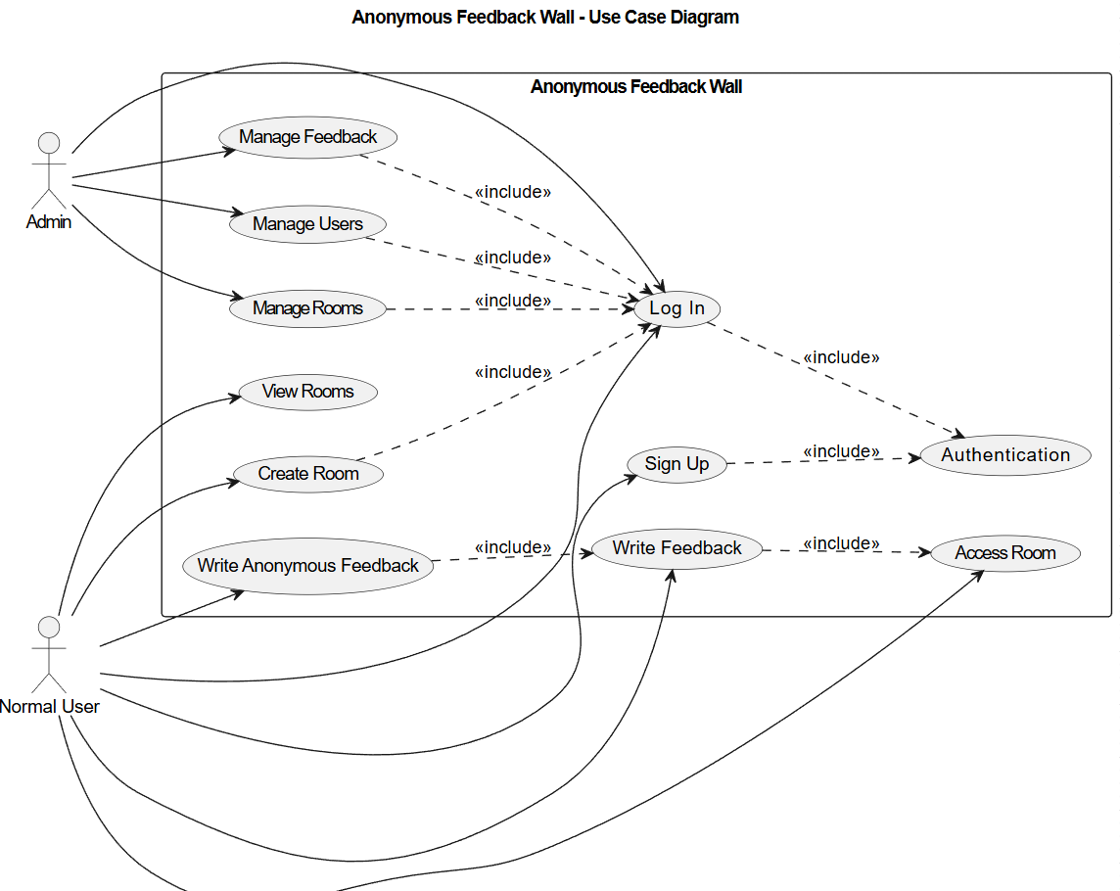

Fig 3.7 : Use case diagram

This diagram shows how users interact with the Anonymous Feedback Wall system. Normal users can sign up, log in, write feedback, and view the feedback wall. Admins log in to manage feedback and manage users. Authentication is a required included process for all protected actions.

### 3.3.6 Sequence diagrams

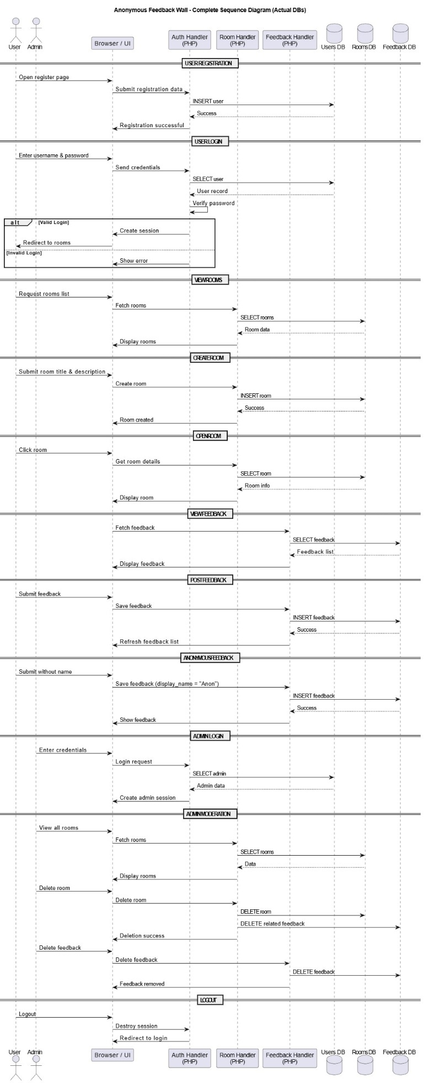

1. User Registration Sequence: The user opens the registration page and submits their details. The system stores the user information in the Users database and confirms successful registration.

2. User Login Sequence: The user enters login credentials. The system verifies the credentials using the Users database and creates a session if valid; otherwise, an error message is shown.

3. View Rooms Sequence: After login, the user requests the list of rooms. The system retrieves room data from the Rooms database and displays it to the user.

4. Create Room Sequence: The user submits a room title and description. The system saves the room details in the Rooms database and confirms room creation.

5. Open Room Sequence: The user selects a room. The system fetches the room details from the Rooms database and displays the selected room.

6. View Feedback Sequence: When a room is opened, the system retrieves all feedback related to that room from the Feedback database and displays it.

7. Post Feedback Sequence: The user submits feedback for a room. The system stores the feedback message in the Feedback database and updates the feedback list.

8. Anonymous Feedback Sequence: If the user does not provide a name, the system saves the feedback with the default display name “Anon” and displays it in the room.

9. Admin Login Sequence: The admin enters login credentials. The system verifies the admin details from the Users database and grants access to the admin dashboard.

10. Admin Moderation Sequence: The admin views all rooms and feedback. The system allows the admin to delete inappropriate rooms or feedback by updating the respective databases.

11. Logout Sequence: The user or admin logs out. The system destroys the session and redirects the user to the login page.

### 3.3.7 Database Schema Diagram

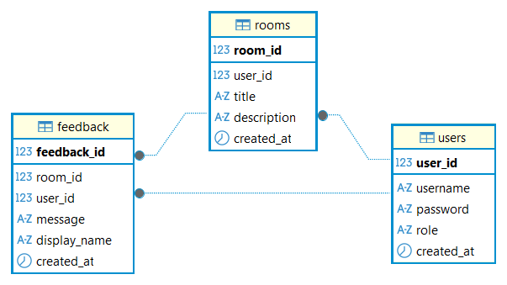

Technically, the diagram uses specific icons to denote Data Types and Primary Keys. Bolded fields like user_id, room_id, and feedback_id are unique identifiers that ensure no two records are identical. The icons indicate whether a field is a number (123), a string of text (A-Z), or a timestamp (clock icon). This structure ensures data integrity, making it easy to track exactly who posted what message and in which room it was shared.

The feedback table consists of feedback_id as primary key, room_id and user_id as foreign keys. Message, display_name and created_at are some data that this table handles and shows.

The room table consists of room_id as primary key and user_id as foreign key. Each room consists of a title and description, and also the date/time it was created in.

The users table consists of user_id as primary key. Each user has a username, password, role and when this user was created.

# CHAPTER 4: SYSTEM IMPLEMENTATION

## 4.1 Project Schedule

### 4.1.1 Detailed Time Schedule

|  |  |  |  |  |
| --- | --- | --- | --- | --- |
| **Task ID** | **Task Name** | **Start Date** | **End Date** | **Duration** |
| **1. Preliminary Work** |  |  |  |  |
| **1.1** | **Planning of project** | **11-Nov** | **12-Nov** | **2** |
| **1.2** | **Analysis of topics** | **12-Nov** | **14-Nov** | **3** |
| **1.3** | **Background Reading** | **14-Nov** | **15-Nov** | **2** |
| **1.4** | **Preliminary Research** | **15-Nov** | **15-Nov** | **1** |
| **2. Research Work** |  |  |  |  |
| **2.1** | **Research on Feedback handling** | **15-Nov** | **17-Nov** | **3** |
| **2.2** | **Rearch on Administrative actions** | **17-Nov** | **19-Nov** | **3** |
| **3. Design and Development** |  |  |  |  |
| **3.1** | **System Architecture Deisgn** | **20-Nov** | **21-Nov** | **2** |
| **3.2** | **Context and DFD Diagram** | **21-Nov** | **21-Nov** | **1** |
| **3.3** | **Designing System Flowchart** | **21-Nov** | **21-Nov** | **1** |
| **3.4** | **Use case diagram** | **22-Nov** | **22-Nov** | **1** |
| **3.5** | **ER Diagram** | **22-Nov** | **22-Nov** | **1** |
| **3.6** | **Sequence Diagram** | **22-Nov** | **22-Nov** | **1** |
| **3.7** | **Schema of Database** | **22-Nov** | **22-Nov** | **1** |
| **4. Coding and Implementation** |  |  |  |  |
| **4.1** | **Code User Interface** | **22-Nov** | **26-Nov** | **5** |
| **4.2** | **Code User sign up and log in** | **26-Nov** | **30-Nov** | **5** |
| **4.3** | **Test User Signup and log in** | **30-Nov** | **5-Dec** | **5** |
| **4.4** | **Code User feedback submission** | **5-Dec** | **30-Dec** | **25** |
| **4.5** | **Test user feedback submission** | **30-Dec** | **01-Jan** | **2** |

Table 4.1 : Detailed Time table

### 4.1.2 Detailed Gantt Chart

## 4.2 Implementation

The Anonymous Feedback Wall system is a web-based application designed to allow users to create discussion rooms and provide feedback in an open and optionally anonymous manner. The overall architecture follows a modular approach, where each major functionality is handled by a separate module to ensure clarity, scalability, and ease of maintenance.

### 4.2.1 User Authentication Module

The user authentication module is responsible for handling user registration, login, and logout functionalities. New users can register by providing a unique username and password, which are securely stored in the Users database using password hashing techniques.

### 4.2.2 Room Management Module

The room management module allows authenticated users to create discussion rooms. Each room consists of a title and a description that defines the topic of discussion. When a user creates a room, the system stores the room details along with the creator’s user ID in the Rooms database.

### 4.2.3 Room Viewing Module

The room viewing module enables users to select and open a specific room. When a room is accessed, the system retrieves the room’s details from the Rooms database and displays them along with the associated feedback. This module ensures that users can easily navigate between rooms and understand the context before submitting feedback.

### 4.2.4 Feedback Submission Module

The feedback submission module allows users to post feedback within a selected room. Users can choose to submit feedback anonymously or provide a display name. If no name is provided, the system automatically assigns the default name “Anon.” Each feedback entry is stored in the Feedback database with references to the corresponding room and user.

### 4.2.5 Feedback Display Module

The feedback display module retrieves and presents all feedback related to a specific room. Feedback entries are displayed in chronological or reverse-chronological order, along with the display name and submission timestamp. This module ensures real-time interaction within rooms and provides a clear discussion flow.

### 4.2.6 Admin Management Module

The admin management module provides additional privileges to administrators. Admin users can view all rooms and feedback entries across the system. They have the authority to delete inappropriate rooms or feedback to maintain platform integrity. Although implemented using the same database tables as normal users, admin actions are controlled through role-based access checks to prevent unauthorized operations.

### 4.2.7 Database Implementation Module

The database integration module manages all interactions with the MySQL database, including user records, room data, and feedback entries. Prepared statements are used throughout the application to prevent SQL injection attacks. The database structure is kept minimal and efficient, consisting only of Users, Rooms, and Feedback tables, ensuring simplicity and performance.

### 4.3 Result

#### 4.3.1 Screenshots

1. Sign up page:

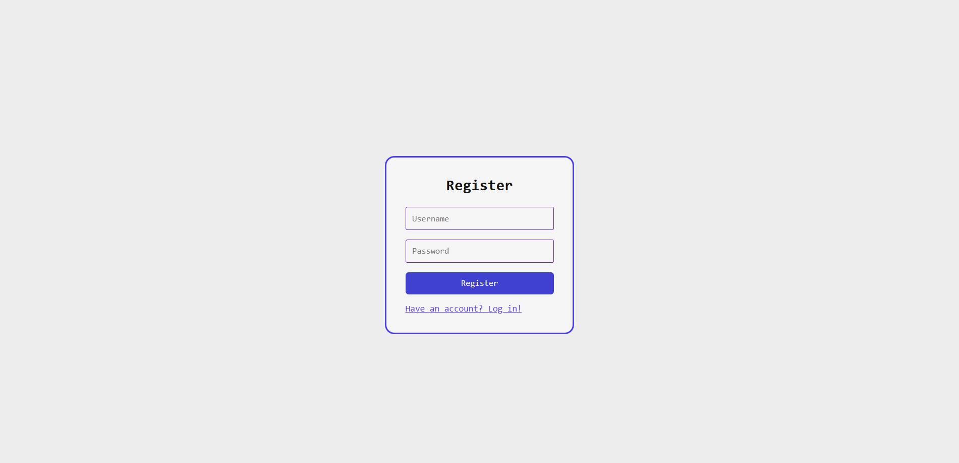

User registration form, this is the page where user registers. The registered data of the user is stored in the database with password being hashed. After registering, the user is redirected to the log in page.

1. Log **in** page: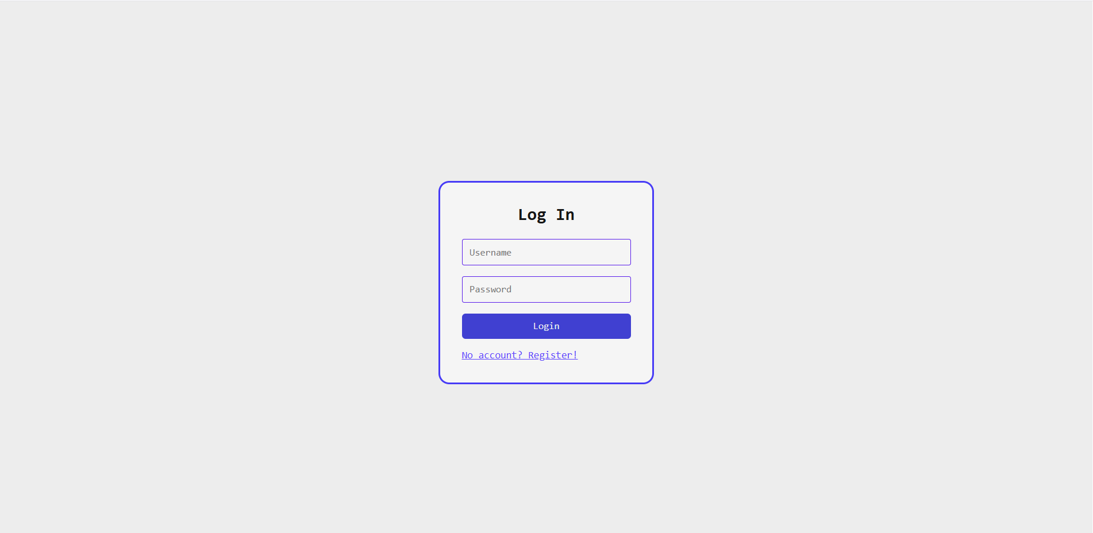

This is where the user is redirected after signing up, this is where user can enter their username and password for authentication which is authorized whether a normal user or an admin logged in and is redirected to their respective pages

1. Rooms page: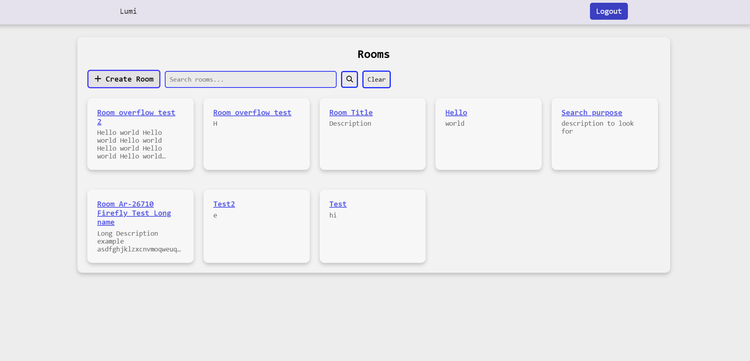

The above page shows rooms page, this is where users can view all available rooms of feedbacks, and also search among them based on room title and description. They can also create their own room by clicking on “+ Create Room” which they will be redirected to create room page

1. Create rooms page: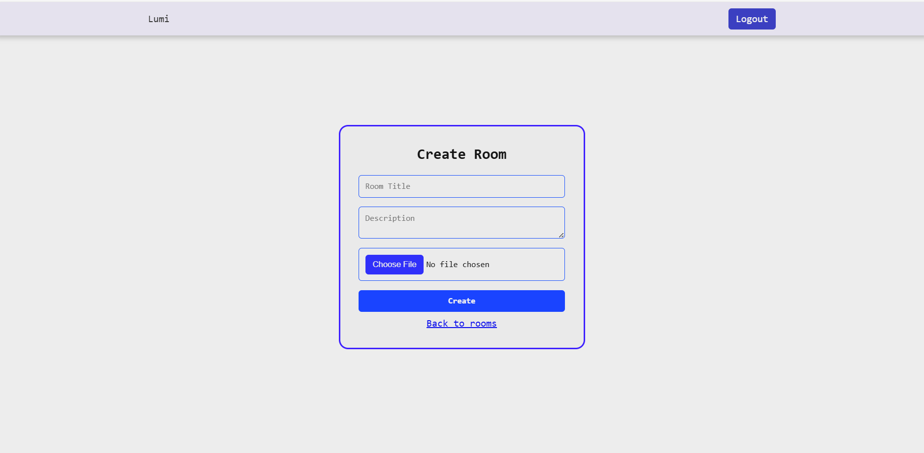

The above page shows the create room page after the user clicks on “+ Create Room” on the rooms page. Here, the user can create a new room based on the feedback they need on. They can enter Room title and description and image(Not functional at the moment).

1. Room page: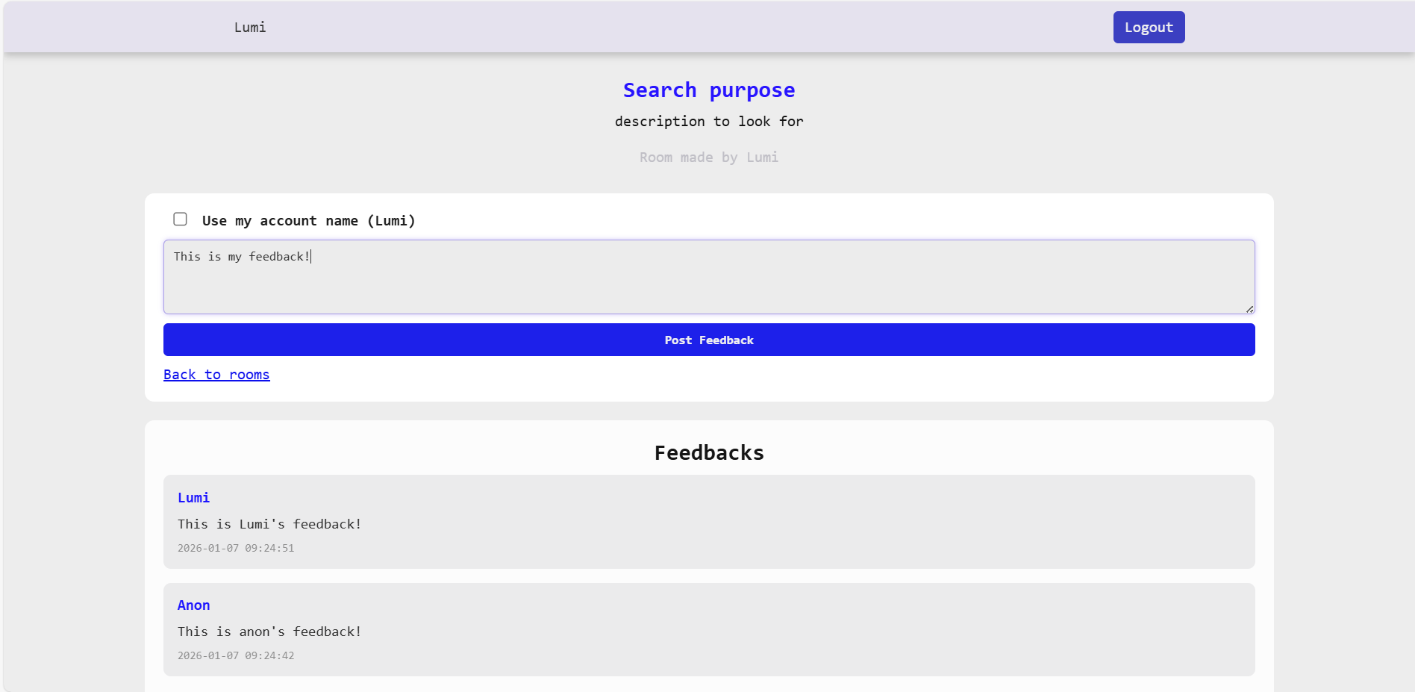

The above page shows the result after clicking on one of the rooms in the rooms page. It is a room where a user can see room’s title, description and author on top. They can post user feedback on the text-area. The submitted result is displayed below in the “Feedbacks” section.

### References

[1] Shaheen, A., Azam, F., & Irshad, K. (2021). Anonymous Feedback: A Real-time Feedback to Capture Students' Engagement in Learning Process. *Proceedings of the International Conference on Medical Education (ICME 2021)*, 65–68.

[2] Frampton, A., Fox, F., Hollowood, A., et al. (2017). Using real-time, anonymous staff feedback to improve staff experience and engagement. *BMJ Quality Improvement Reports*,

[3] Harrison, C. J., Könings, K. D., Molyneux, A., Schuwirth, L. W., Wass, V., & van der Vleuten, C. P. (2013). Web‐based feedback after summative assessment: how do students engage?. *Medical education*, *47*(7), 734-744.

[4] van Kol, S., & Rietz, C. (2016). Effects of Web-Based Feedback on Students' Learning. *International Journal of Teaching and Learning in Higher Education*, *28*(3), 385-394.

[5] Golchevskiy, Y., & Yermolenko, A. (2021). Implementation of Feedback as an Important Element of Modern Corporate Websites. *Journal of Information and Organizational Sciences*, *45*(2), 399-409.

[6] Piatnychuk, I., Boryshkevych, I., Tomashevska, A., Hryhoruk, I., & Sala, D. (2022). Online tools in providing feedback in management. *Journal of Vasyl Stefanyk Precarpathian National University*, *9*(3), 6-17.

[7] Scherr, S. A., Elberzhager, F., & Holl, K. (2017, August). An automated feedback-based approach to support mobile app development. In *2017 43rd Euromicro Conference on Software Engineering and Advanced Applications (SEAA)* (pp. 44-51). IEEE.

[8] Soriguera, F., & Miralles, E. (2016). Driver feedback mobile app. *Transportation research procedia*, *18*, 264-271.

[9] Scherr, S. A., Ter-Tovmasyan, M., Neugebauer, F., Hupp, S., & Elberzhager, F. (2022). The way it made me feel-Creating and evaluating an in-app feedback tool for mobile apps. *J. Ubiquitous Syst. Pervasive Networks*, *17*(1), 27-34.

[10] Fu, B., Lin, J., Li, L., Faloutsos, C., Hong, J., & Sadeh, N. (2013, August). Why people hate your app: Making sense of user feedback in a mobile app store. In *Proceedings of the 19th ACM SIGKDD international conference on Knowledge discovery and data mining* (pp. 1276-1284).